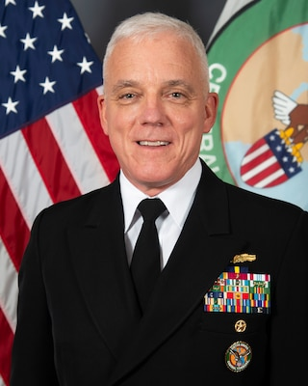
Download

Deputy Commander, Vice Admiral James Malloy
Vice Adm. James Malloy is a native of Silver Spring, Maryland and a 1986 graduate of the U.S. Naval Academy. He holds a Master of Science in Systems Technology (Command, Control and Communications) from the Naval Post Graduate School; a Master of Science in National Security Strategy from the National War College and a Master of Health Sciences in Emergency and Disaster Management from Touro University.
His sea tours include assignments onboard USS Deyo (DD 989), USS Fahrion (FFG 22) and USS Benfold (DDG 65). He deployed in command of both USS Falcon (MHC 59) and USS Pinckney (DDG 91), guiding Pinckney through her maiden deployment. He commanded Destroyer Squadron 50 as commander, Middle East Force (CTF 55) and commander, Coalition Task Group 152.1 operating at sea and from naval command centers in Kuwait, Bahrain, and the United Arab Emirates.
Ashore, Malloy served as the Navy theater missile defense officer and commander in chief operations briefer at U.S. Central Command (J3) in Tampa, Florida. Following the 9/11 terror attack, he established U.S. Naval Forces Central Command Friendly Forces Coordination Cell in Bahrain, as deputy for the operational liaison staff.
Other staff assignments include flag aide to Commander, U.S. Naval Forces Central Command/U.S. 5th Fleet in Bahrain; initial requirements officer for the Littoral Combat Ship on the staff of the Chief of Naval Operations, Surface Warfare Directorate (N86); head, Washington Placement Branch at Naval Personnel Command (PERS 441) and assistant deputy director, Politico-Military Affairs in the Strategic Plans and Policy Directorate (J5) on the Joint Staff.
As a flag officer, his tours include deputy director of operations, U.S. Central Command (J3); commander, Carrier Strike Group 10, deploying with USS Dwight D. Eisenhower (CVN 69) to U.S. European Command and U.S. Central Command areas of responsibility in support of Operation Inherent Resolve; vice director for operations, the Joint Staff (J3); deputy chief of naval operations for Operations, Plans and Strategy (N3/N5); and commander, U.S. Naval Forces, U.S. Central Command, U.S. 5th Fleet, Combined Maritime Forces.
Malloy began serving as deputy commander, U.S. Central Command September 21, 2020

